Author Agreement Statement

We the undersigned declare that this manuscript is original, has not been published before and is not currently being considered for publications elsewhere.
We confirm that the manuscript has been read and approved by all named authors and that there are no other persons who satisfied the criteria for authorship but are not listed. We further confirm that the order of authors listed in the manuscript has been approved by all of us.
We understand that the Corresponding Author is the sole contact for the Editorial process. He/she is responsible for communicating with the other authors about progress, submissions of revisions and final approval of proofs.
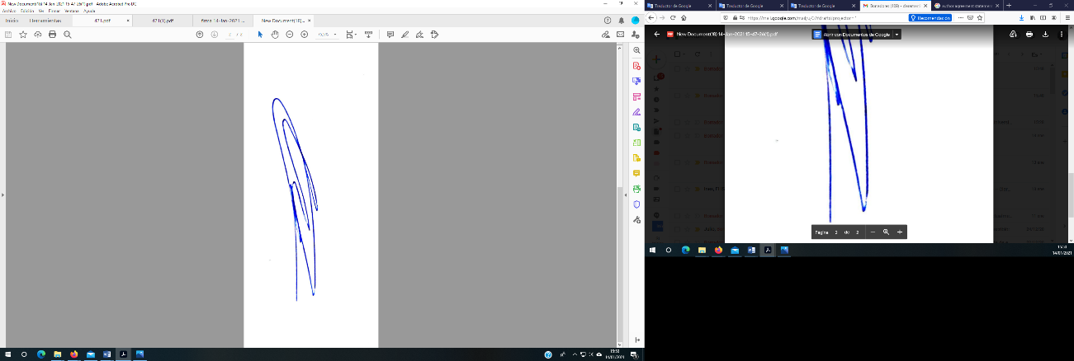
Signed by all authors as follows:
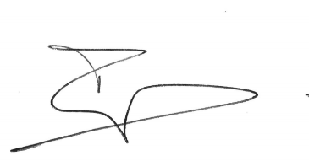
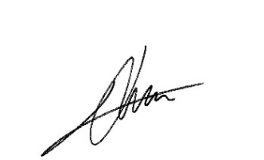
Luis Jimenez-Treviño Clara Martínez-Cao Celso Iglesias

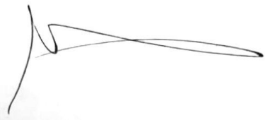
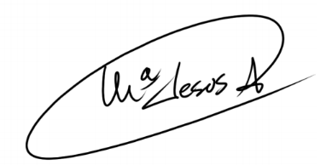
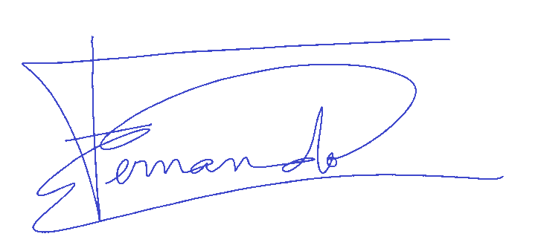

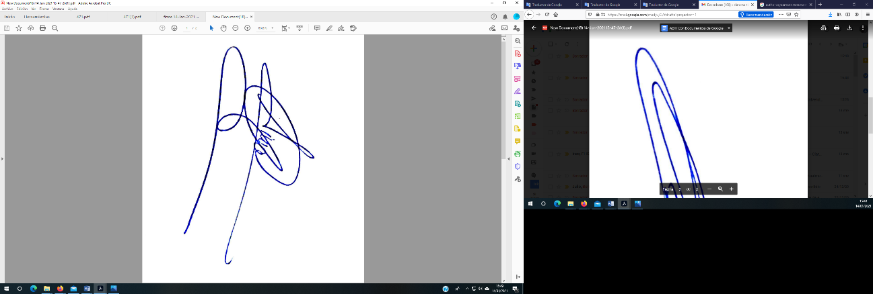
Fernando Sánchez-Lasheras María Jesús Antuña Leonor Riera
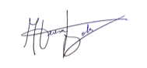
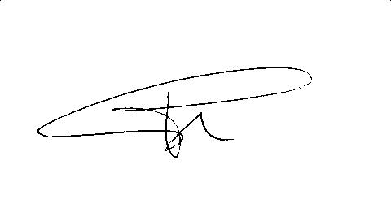

Teresa Bobes-Bascarán Ainoa García-Fernández Pilar A.Sáiz
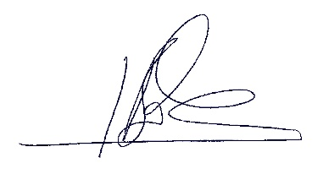

Julio Bobes

