Supplementary material (SM).
Figure 1-SM. Prevalence of ANT among cases and controls.

Figures 2-SM and 3-SM. Differences in the addiction to NT in cases and controls separated by age (7-11 and 12-17 years old).
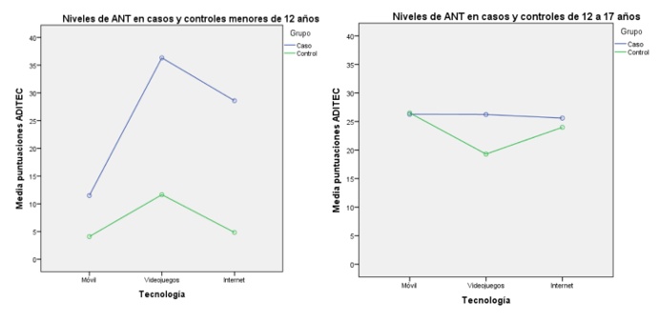

Regarding age, all three bifactorial analyses were resounding: the estimate of effect size was greater than 0.14 (η2=0.309) in children aged 7 to 11 years old in the three analyses. This difference is important (Pardo, A. San Martín, R., 2015). Thus, our findings suggest that younger age contributes to the differences between groups (cases-controls), between types of ADHD and ANT, and within the interaction ADHD-ANT.

Table 1-SM. Perception of an ANT by parents (responses to question 1 of the ad hoc questionnaire).
 | No | Mobile | Video games | Internet | Several | Global
Cases | 11 (24.4%) | 6 (13.1%) | 14 (31.1%) | 12 (26.7%) | 2 (4.4%) | 45 (100%)
Controls | 10 (27%) | 9 (24.3%) | 12 (32.4%) | 5 (13.5%) | 1 (2.7%) | 37 (100%)
Global | 21 (25.6%) | 15 (18.3%) | 26 (31.7%) | 17 (20.7%) | 3 (3.7%) | 82 (100%)

Table 2-SM. Ad hoc questionnaire about a putative ANT (parents).
Item | Cases  (%) | Controls  (%) | Significance
1. Do you think your child has an addiction to any of the following technologies? |  |  | ns
2. Has your child got the urge to use new technologies (mobile, video games, or the Internet) to relieve tension, relax, or decrease psychological distress in the past year? |  |  | ns
3. Has your child been using new technologies more frequently or longer lasting than initially planned? |  |  | ns
4. Does your child have a persistent desire to quit the use of new technologies, but is unable to stop? |  |  | ns
5. Has your child ever missed or reduced a social engagement, work, school, or other recreational activities because he/she was involved in activities related to new technologies? | 46.7 | 21.6 | p=0.018
6. Does your child continue using new technologies despite knowing the problems related to its use? |  |  | ns
7. Has your child tried to stop using new technologies, but is unable to do so or it took him/her a lot of effort? |  |  | ns
8. Do you feel that your child needs to spend more and more time on new technologies in order to feel good, less anxious, or emotionally fine? | 44.4 | 2.7 | p<0.05
9. Does your child feel a strong desire to use new technologies even without any particular reason? | 64.4 | 16.2 | p<0.05
10. Has your child gotten into trouble at school/work/home due to new technologies? | 42.2 | 0 | p<0.05
11. Does your child use new technologies in situations in which it is physically hazardous? (i.e., crossing a road while using mobile phone) | 22.2 | 0 | p<0.05
12. Does your child feel bad, anxious or annoyed when he/she wishes to use new technologies but cannot do so at the time? |  |  | ns

