UNIVERSIDAD DE ALCALÁ, PATRIMONIO DE L A H U M A N I D A D

July 5th, 2019

Pilar Alejandra Sáiz Editor-in-Chief
Adicciones

Dear, Pilar Alejandra Sáiz

Please find enclosed our manuscript titled “Availability and promotion of alcohol across different outlets typologies and under different area-level socio-economic status” for your consideration for publication in Adicciones.
Alcohol is one of the leading factors associated with disability and death worldwide. Alcohol consumption has been associated with the characteristics of the urban environment. The aim of this study was to characterize the availability and promotion of alcohol at the point of sale in the city of Madrid, Spain, through social systematic observation.

The results of this study showed the wide availability and accessibility of alcohol products, and the ubiquitous alcohol promotion at point of sale in the urban environment. This exposure was higher for on-premise alcohol outlets. Moreover, we also found some differences in alcohol exposure according to area-level socioeconomic status. Wider hours of sale and more outlets with at least one sign of alcohol promotion were found in higher socio-economic areas, making alcohol exposure higher in these areas.

These results may help to design specific alcohol interventions that contributes to denormalization of alcohol consumption allowing to reduce alcohol-health burden and health inequalities. To our knowledge, this is the first study that described comprehensively availability, and promotion of alcohol associated to on-and off-premises alcohol outlets and compare differences between them. We believe that the results and implications of this study may be of the interest of the international audience of Adicciones.

UNIVERSIDAD DE ALCALÁ, PATRIMONIO DE L A H U M A N I D A D
The funding source of this article were the Plan Nacional sobre Drogas (grant number: 2016I047) and the Heart Healthy Hoods project. The Heart Healthy Hoods project was funded by the European Research Council under the European Union’s Seventh Framework Programme (FP7/2007– 2013/ERC Starting Grant Heart Healthy Hoods Agreement no. 623 336893). The funding sources have not any involvement in the study design; in the collection, analysis, or interpretation of data; in the writing of this work; or in the decision to submit the manuscript for publication

All the authors carefully read the manuscript and fully approved of it. All the authors declare to have no conflict of interest. In their name I also declare that the manuscript is original and it is not submitted anywhere other than your journal.

Correspondence about the manuscript should be addressed to Dr. Sureda as indicated in the first page of the manuscript. As the corresponding author, I confirm my personal full access to all aspects of the research and writing process, and taking final responsibility for the paper.

Suggested reviewers for the manuscript: Mariana Lazo (mlazoel1@jhmi.edu), Niamh Fitzgerald (niamh.fitzgerald@stir.ac.uk) and Francisco Caamaño (francisco.caamano@usc.es).

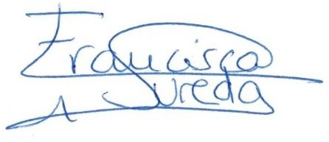
Thank you very much for your kind attention. Yours sincerely,
Francisca Sureda (corresponding author)
Social and Cardiovascular Epidemiology Research Group, School of Medicine, University of Alcalá.
Campus Universitario - Crta. de Madrid-Barcelona, Km. 33,600. Alcalá de Henares, Madrid, 28871 Spain.
Telf: +34 918 222 351
E-mail: fancisca.sureda@uah.es

UNIVERSIDAD DE ALCALÁ, PATRIMONIO DE L A H U M A N I D A D



Andrea Pastor
Social and Cardiovascular Epidemiology Research Group, School of Medicine, University of Alcalá.


Albert Espelt
Facultat de Ciències de la Salut de Manresa, Universitat de Vic Universitat Central de Catalunya.


Joan R Villalbí
Agència de Salut Pública de Barcelona


Lucia Moure
Instituto de Investigación Sanitaria Galicia Sur. Complexo Hospitalario Universitario de Ourense

UNIVERSIDAD DE ALCALÁ, PATRIMONIO DE L A H U M A N I D A D

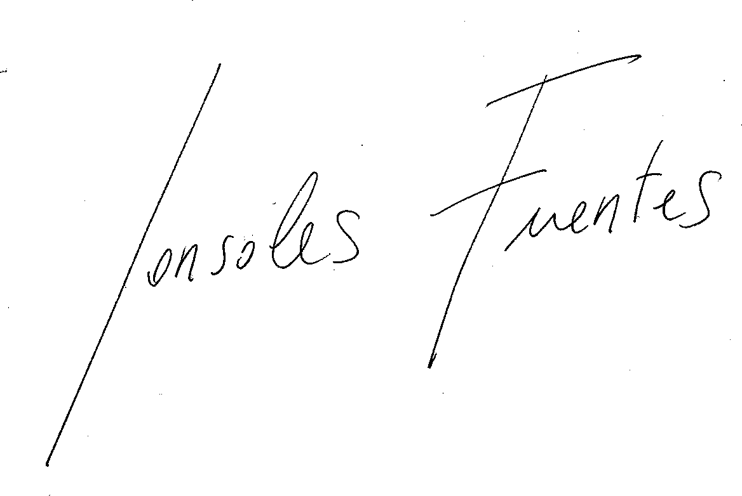

Sonsoles Fuentes
Non-Communicable Diseases and Trauma Division, Santé publique France.


Niamh K Shortt
Centre for Research on Environment, Society and Health, School of GeoSciences, University of Edinburgh.



Manuel Franco
Social and Cardiovascular Epidemiology Research Group, School of Medicine, University of Alcalá



Roberto Valiente

Departamento de Geología, Geografía y Medioambiente, Universidad de Alcalá.

UNIVERSIDAD DE ALCALÁ, PATRIMONIO DE L A H U M A N I D A D



Luisa N. Borrell
Department of Epidemiology & Biostatistics, Graduate School of Public Health & Health Policy, City University of New York, New York, NY 10027, USA.

